ZS-408-S Online Turbidity Sensor
User Manual
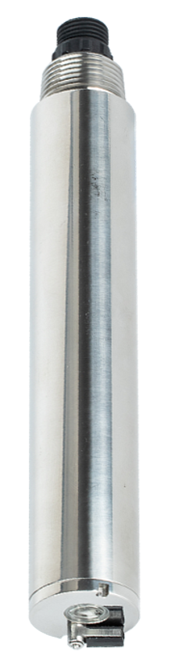
Hangzhou Chemins Tech Co., Ltd.
Yantai Chemins Instrument Co., Ltd.
Tel：0535-3463801/89870583
E-mail：service@chemins-tech.com ; info@chemins-tech.com
Website：www.chemins-tech.com
Address: Room 902, Building 19, No. 260, 6th Street, Baiyang Street, Qiantang District, Hangzhou, China (Zhejiang) Pilot Free Trade Zone
10 Ankang Nan Lu, Zhaoyuan Economic and Technological Development Zone, Yantai City, Shandong Province, China
User Notes

- Please read this manual carefully before use and save it for reference
- Please follow the operating procedures and precautions in this manual.
- When receiving the instrument, please carefully open the package to check whether the instrument and accessories are damaged due to shipping. If any damage is found, please inform the manufacturer and distributor immediately, and keep the package for return.
- When the instrument fails, don’t repair it yourself. Please contact the after-sales department of the manufacturer directly.

Content
Ⅰ.Working principle 4
Ⅱ.Technical performance and specifications 4
1. Technical parameters 4
2. Dimensional drawing 5
Ⅲ.Installation and electrical connection 5
1. Install 5
2. Electrical connection 5
Maintenance 6
1. Maintenance procedures and methods 6
2. Calibration of sensors 6
3. Frequently asked questions 7
Ⅴ.Quality and service 7
1. Quality assurance 7
2. Spare parts 7
3. After-sales service commitment 7
Appendix data communication 8

Ⅰ.Working principle
ZS-408-S integrated online turbidity sensor is designed and manufactured using the principle of scattered light turbidity measurement. When a beam of light enters the water sample, the light is scattered by the turbidity material in the water sample. By measuring the scattered light intensity in the vertical direction to the incident light and comparing it with the internal calibration value, the turbidity in the water sample is calculated. degree, and output the final value after linearization.

- 90° angle scattered light principle, built-in temperature sensor
- Support RS-485, Modbus/RTU protocol, 4-20mA current output
- Optical fiber structure, strong resistance to external light interference
- Infrared LED light source, high stability
- IP68 protection, water depth within 20 meters
- Convenient, fast, stable and easy to maintain

Ⅱ.Technical performance and specifications

Technical parameters
Model | ZS-408-S
Case Material | 316L
Measurement Principle | Scattered light method
Range and resolution | 0~20.00 NTU | 0.01
 | 0~1000.0 NTU | 0.1
 | 0~4000.0 NTU | 0.1
Accuracy | ±3% or ±1.5 NTU, whichever is greater  ±5% or ±3 NTU, whichever is greater  0-200 NTU：±20 NTU；200-4000 NTU：±5%；±0.3℃
Response time (T90) | ＜30s
Minimum detection limit | 0.01（0-20NTU）
 | 0.3NTU
Calibration method | Two-point calibration
Cleaning method | Built-in cleaning brush
Temperature compensation | Automatic temperature compensation (Pt1000)
Output method | RS-485 (Modbus RTU), 4-20 mA (optional)
Storage temperature | -5～65℃
Working conditions | 0～60℃, ≤0.2MPa
Installation method | Submersible installation, 3/4 NPT
Power consumption | 0.2W@12V
Power supply | 12～24V DC
Protection level | IP68
Cable length | 5 meters, other lengths can be customized

Dimensional drawing
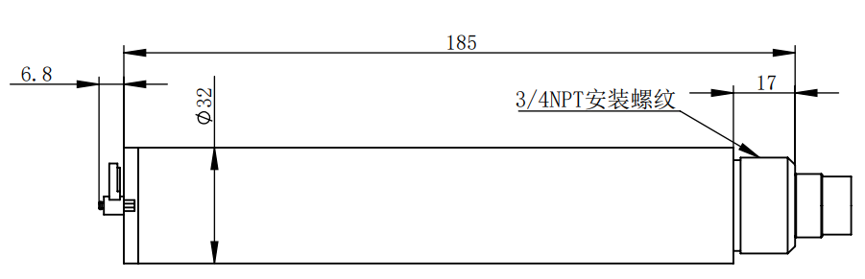
Note:The sensor connector is m16-5 core waterproof connector male.

Ⅲ.Installation and electrical connection

Install
Installation distance requirements: keep above 5cm with side wall and above 10cm with bottom.

Electrical connection
- Red wire-power cord（12～24V）
- Black wire-ground wire（GND）
- Blue Line-485A
- White Line-485B
- Yellow line—current output (optional, can be left floating if not used)
After the wiring is completed, it should be carefully checked to avoid the wrong connection before the power is turned on.

Cable specification: Considering that the cable is immersed in water (including sea water) for a long time or exposed to the air, all the wiring points are required to do waterproof treatment, the user cable should has certain corrosion resistance.

Maintenance

Maintenance procedures and methods

1.1 Maintenance schedule
The cleanliness of the measuring window is very important for maintaining accurate readings.
Maintenance task | Recommended maintenance frequency
Calibrate sensors  (If required by the competent authority) | According to the maintenance schedule required by the competent department

1.2 Maintenance method
- Sensor outer surface: clean the outer surface of the sensor with tap water, if there is still debris residue, wipe with wet soft cloth, for some stubborn dirt, you can add some household washing liquid to tap water to clean.
- Check the cable of the sensor: the cable should not be tightened when it is working properly, otherwise it is easy to break the wire inside the cable and make the sensor unable to work properly.
- Check the sensor measurement window if there is any dirt, cleaning brush is normal.
1.3 Note:
The probe contains sensitive optical and electronic components. Make sure the probe is not subjected to severe mechanical impact. There are no components inside the probe that need to be maintained by the user。

Calibration of sensors
- Zero calibration: take proper amount of zero turbidity solution with large beaker, put the sensor vertically in the solution, the front end of the sensor is at least 10 cm from the bottom of the beaker, and the zero calibration will be carried out after the value is stabilized for 3-5 minutes. The instructions refer to the appendix.

- Slope calibration: the sensor probe is placed in the standard solution, the front end of the sensor is at least 10 cm from the bottom of the beaker, and the slope calibration is carried out after 3 -5 minutes of numerical stability. The instructions refer to the appendix.

Frequently asked questions
Wrong | Probable cause | Resolvent
The operating interface cannot connect or does not display the measurement results | The measured value is too high, too low, or the numerical value remains unstable. | Reconnect the controller and cable.
 | Cable failure | Please contact us.
The measured value is too high, too low, or the numerical value remains unstable. | The sensor window is attached to the external object. | Clean the window surface of the sensor.

Ⅴ.Quality and service

Quality assurance
- The quality inspection department has a standard inspection procedure, with advanced and complete detection equipment and means, and according to the procedure inspection, the product is subjected to 72-hour aging experiment and stability experiment, so that a non-conforming product is not allowed to leave the factory.
- The consignee shall refund directly the product batches with a failure rate of 2%, and all expenses incurred shall be borne by the supplier. Consider the standard reference to the product description provided by the supplier.
- Ensure the quantity of goods and the speed of shipment.

Spare parts
This product includes:
- Transmitter *1
- copy of explanation*1
- certificate of quality*1
- cable (5 meters)*1

After-sales service commitment
The Company has provided the local after-sales service within one year from the date of sales, but does not include the damage caused by improper use. If it is necessary to repair or adjust it, please return it, but the freight is required to be self-contained. When it is returned, it shall be confirmed that the package is good to avoid damage during transportation. The Company will repair the damage of the instrument free of charge.

Appendix data communication

- Data format
The default data format for Modbus communication is: 9600, n, 8, 1 (baud rate 9600bps, 1 start bit, 8 data bits, no check, 1 stop bit)。
- Information frame format (xx for one byte)
- Read data instruction frame
07 03 xx xx xx xx xx xx
Address FC Register start address Number of registers CRC check code
(low bytes in front)

- Read data response frame
07 03 xx xx……xx xx xx
Address FC Bytes Response data CRC check code(low bytes in front)

- Write data instruction frame
07 06 xx xx xx xx xx xx
Address FC Register address read-in data CRC check code(low bytes in front)

- Write data response frame (co-write data instruction frame)
07 06 xx xx xx xx xx xx
Address FC Register address read-in data CRC check code(low bytes before）

- Register address
Register address | Designation | Explain | Number of registers | Access mode
40001  (0x0000) | Measured temperature | 4 double-byte integers, which are the measured values, the number of decimal places, the temperature value, and the number of decimal places of the temperature value, respectively. | 4 (8 bytes)） | Read
44097  (0x1000) | Zero calibration | - The 0-20NTU measurement range is calibrated in the 0-10NTU turbidity solution, and the written data is the actual value of the standard solution ×100;The 0-100NTU measurement range is calibrated in the 0-20NTU turbidity solution, and the written data is the actual value of the standard solution ×10;The measuring range of 0 ~ 1000NTU is calibrated in the turbidity solution of 0 ~ 200NTU, and the written data is the actual value of the standard solution ×10；Readout value is zero offset. | 1(2 bytes) | Write/ Read
44101  (0x1004) | Slope calibration | The 0-20NTU range is calibrated in a turbidity solution of 10-100NTU, and the written data is the actual value of the standard solution ×100;The measuring range of 0 ~ 100NTU is calibrated in the turbidity solution of 20 ~ 200NTU, and the written data is the actual value of the standard solution ×10;The measuring range of 0 ~ 1000NTU is calibrated in the turbidity solution of 200 ~ 1000NTU, and the written data is the actual value of the standard solution ×10; the readout value is slope value ×10. | 1（2 bytes） | Write/ Read
44113  (0x1010) | temperature correction | Calibrate in the solution, the written data is the actual temperature value × 10, and the readout data is the temperature calibration offset × 10. | 1（2 bytes） | Write/ Read
48195  (0x2002) | Sensor address | The default is 6, and the write data range is 7-255. | 1(2 bytes)） | Write/ Read
48196  (0x2003) | Baud rate | The default is 9600. 0--9600, 1--19200. | 1(2 bytes)） | Write/ Read
44865  （0x1300） | Automatic cleaning interval setting | The default is 30 minutes, and the data range is 6 to 6000 minutes. | 1(2 bytes)） | Write/ Read
44866  （0x1301） | Automatic cleaning lap setting | The default is 3 circles, and the data range is 0~6 circles. | 1(2 bytes)） | Write/ Read
48225  (0x2020) | Reset sensor | The calibration value is restored to the default value and the write data is 0. Note that the sensor needs to be re-calibrated after it has been reset before it can be used. | 1（2 bytes） | Write

- Command example
a) Measurement instructions
Function: Get the turbidity and temperature measured by the sensor; the unit of turbidity is NTU, and the unit of temperature is °C.
Request frame: 07 03 00 00 00 04 44 6F
Response frame: 07 03 08 01 02 00 01 00 B0 00 01 94 B4
Reading example:
Turbidity value | Temperature value
01 02 00 01 | 00 B0 00 01

For example: turbidity value 01 02 represents the hexadecimal reading turbidity value, 00 01 represents the turbidity value with 1 decimal point, and the converted decimal value is 25.8.
The temperature value 00 B0 represents the hexadecimal reading temperature value, and 00 01 represents the temperature value with 1 decimal point converted into a decimal value of 17.6.
b) Calibration instructions
Zero point calibration
Function: Set the zero point calibration value of the sensor;
Zero point calibration example (calibrated in the 50NTU standard, the written value is 50×10=500, which is 0x01F4):
Request frame: 07 06 10 00 01 F4 8D 7B
Response frame: 07 06 10 00 01 F4 8D 7B
slope calibration
Function: Set the slope calibration value of the sensor;
Slope calibration example (calibrated in 2000NTU standard solution, write the value as 2000×10=20000, which is 0x4E20):
Request frame: 07 06 10 04 4E 20 F8 D5
Response frame: 07 06 10 04 4E 20 F8 D5
c) Set device ID address:
Function: Set the MODBUS device address of the sensor;
Change the sensor address 07 to 01, the example is as follows
Request frame: 07 06 20 02 00 01 E2 6C
Response frame: 07 06 20 02 00 01 E2 6C
5. Error response
If the sensor does not execute the upper computer command correctly, the following format information is returned:
Definition | Address | Function code | Code | CRC check
Data | ADDR | COM+80H | xx | CRC 16
Number of bytes | 1 | 1 | 1 | 2

- CODE：01 – Functional code error
03 – Data error
- COM：Received function code

